**Project 2: Visualize Me, Captain!**

**Project Name: Marine Terminal Planning**

**Group: Cody Stegall and Matt Shaffer**

**A brief articulation of your chosen topic and rationale:**

We are combining data from many sources to create parallel relationships in one dashboard visualization. The primary data sources we will be using are API, web-based extraction for HTML and JSON, and SQL server. The parallel relationships we are creating from these data sources will be used to create visualizations that allow our team to pinpoint one or multiple areas of focus in order to forecast and plan terminal operations. The analysis of this data will allow our team to perform root cause analysis and focus on operational pinch points that are not outwardly visible during a given vessel, yard, or rail operation.

**A link to your data set(s) and a screenshot of the metadata if it exists:**

Our data is housed on proprietary company servers, and we are not able to grant access to them, however, please see a screen shot below of the output from those servers.

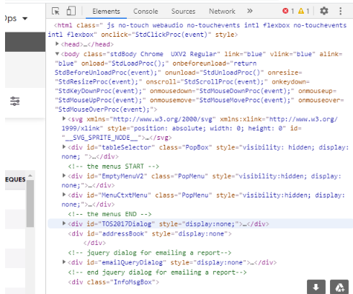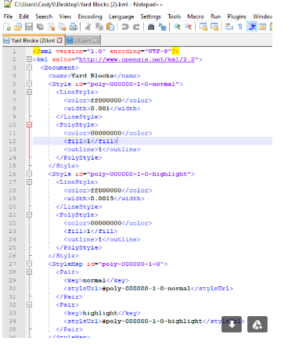

**3 or 4 screenshots of relevant visualizations that frame your creative fodder:**

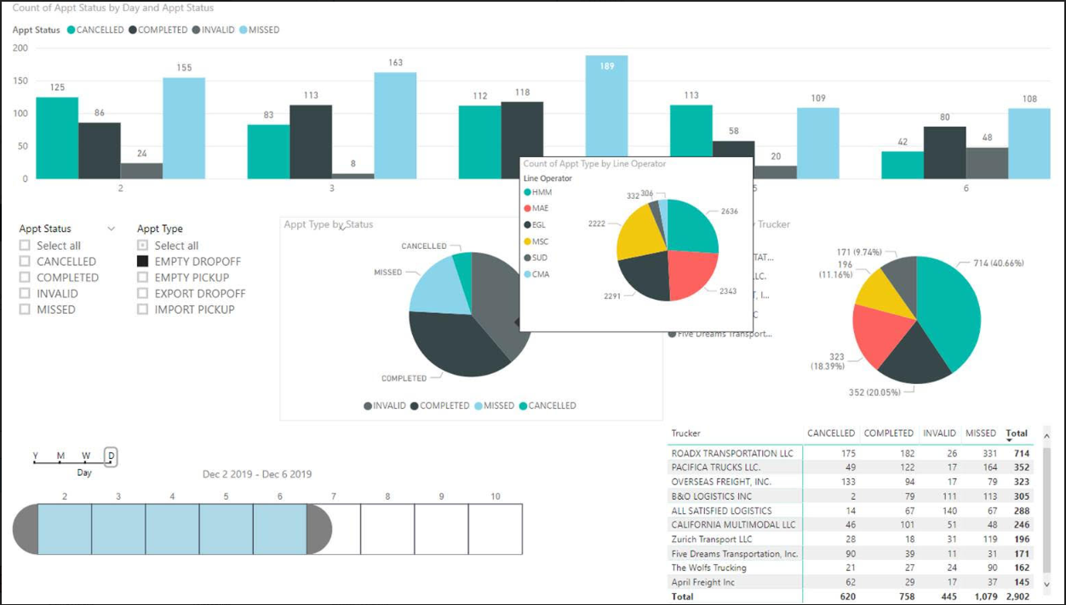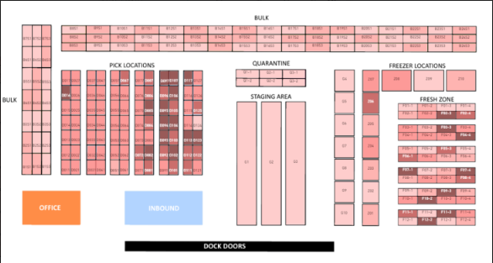

**A sketch of the final design:**

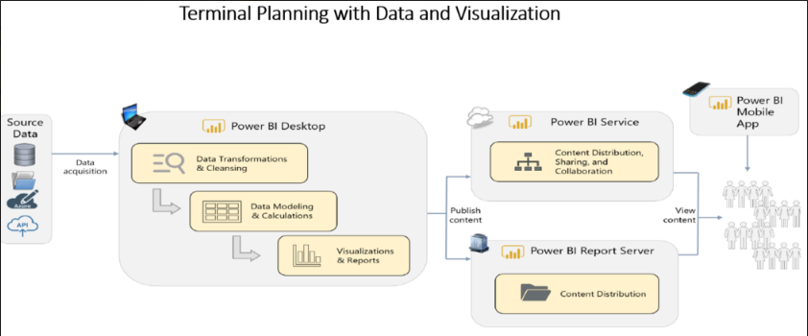

**Link to the primary GitHub repository you will be housing your work in:**

<https://github.com/MattShaffer/Project-2.git>